Tetris (1989, NES), Nintendo. GAMEPLAY

1. Composition
Tangible space | An abstract rectangle of empty space which the player progressively fills.
Intangible space | Information displays.
Negative Space | Ornamental wall of gray tetriminoes .
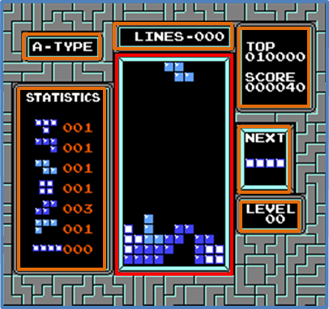
External | Zero ergodic
2. Ocularization

3. Framing mechanisms | Anchor : Anchorless | Mobility : Fixed

4. Plane Analysis
 | Agents | In-game | Off-game
Graphical materials | Raster graphics (sprites) | Blank | Raster graphics (sprites)
Projection method | Orthogonal |  | Orthogonal
Angle of projection | Horizontal |  | Horizontal

Notes :
The player controls a single tetrimino at a time, progressively filling up the in-game environment through his agency. The data bands in the intangible space can play a role in the gameplay process – mainly the « NEXT » window, which displays the upcoming piece and has strategic importance for the player to keep track of.

There is no off-game space, since the in-game space needs clear boundaries to emphasize the confined nature of the game situation. However, some other games in the genre, such as Tetris Worlds, have tried to instill a sense of connectedness between the in-game and off-game environment with integrated backgrounds and events.

